Name | skate | ski | Play snowballs | Make a snowman | Play computer games | Study English | Help Mom
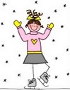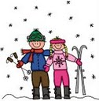When do you _____________?
I _____________on Monday.

