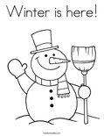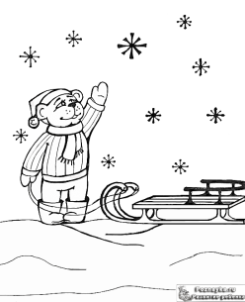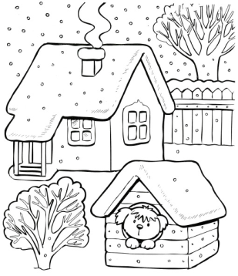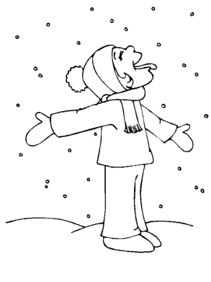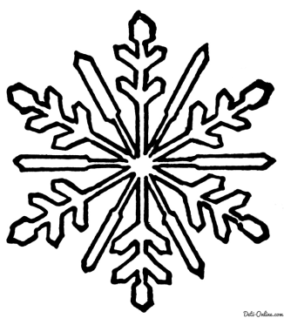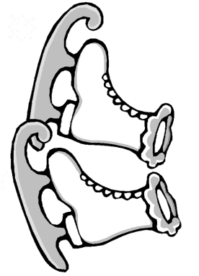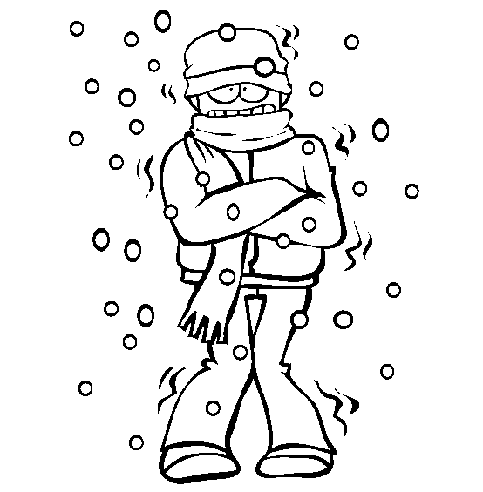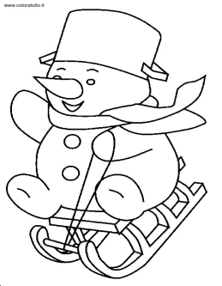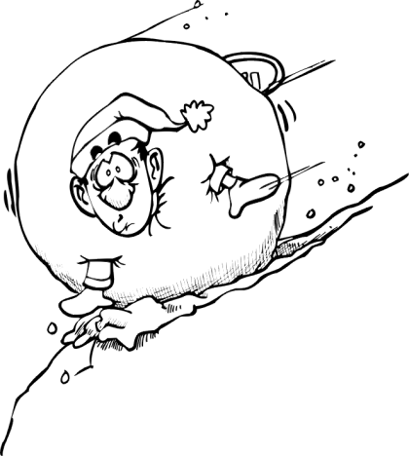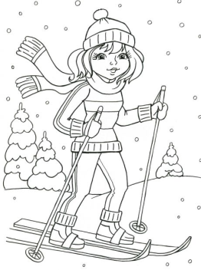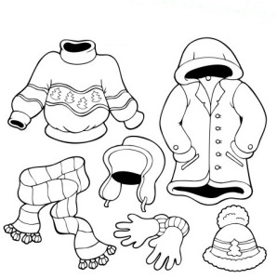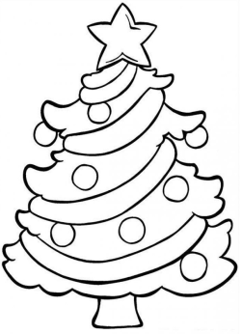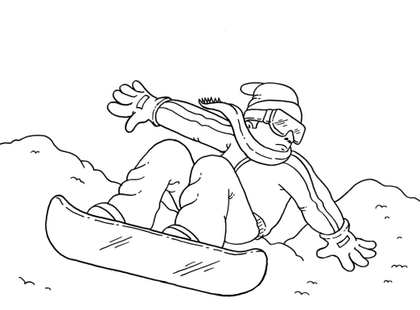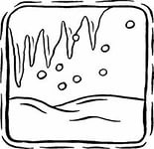

Please unscramble the words below

1. WRNITE_________________________________

2. SNWO_________________________________ __

3. SWOENKAFL______________________________

4. LDCO __________________________________

5. GIEDSLND________________________________

6. SNWOBLAL___ _____________________________

7. GSKNII ___________________________________

8. IEICSCL ___________________________________

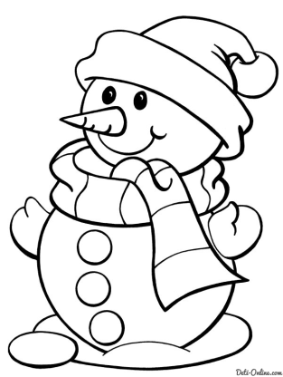

**Complete the text.**

snowboarding, cold, snowball, winter,

skiing, snowman, snowing

I like ___________ because I often go ___________ or ___________ to the mountains. I like walking when it’s ___________ and although it is ___________, the air is fresh. We often have a ___________ fight or make a ___________ with my friends.



Winter

Sledding

Skiing

Icicles

Snowflake

NewYear

Cold

Skates

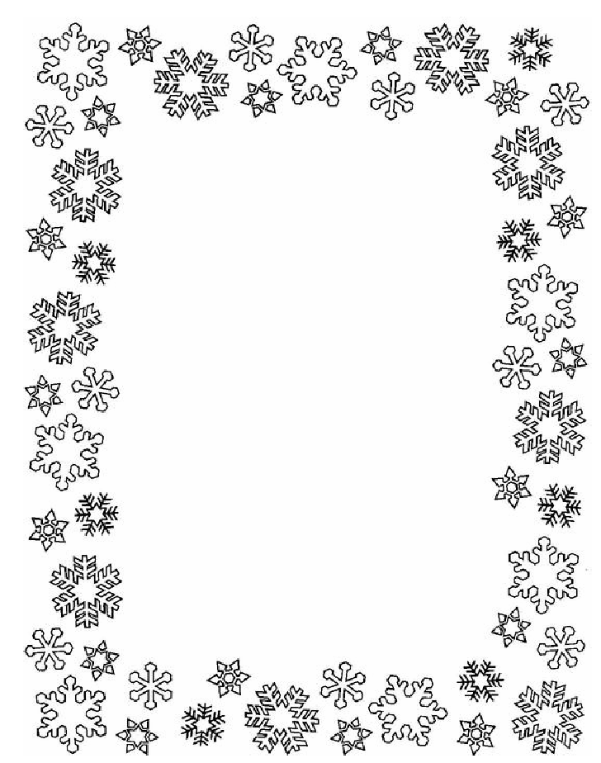

**Snow.**

The snowflakes are falling

By one’s and by two’s.

There is snow on my coat

And snow on my shoes.

There is snow on the plants

And snow on the trees.

And snowflakes all around me

Like many white bees!

**It’s winter!**

It’s winter, it’s winter,

Let us skate and ski!

It’s winter, it’s winter,

It’s great fun for me!

Describe a picture using Present Continious

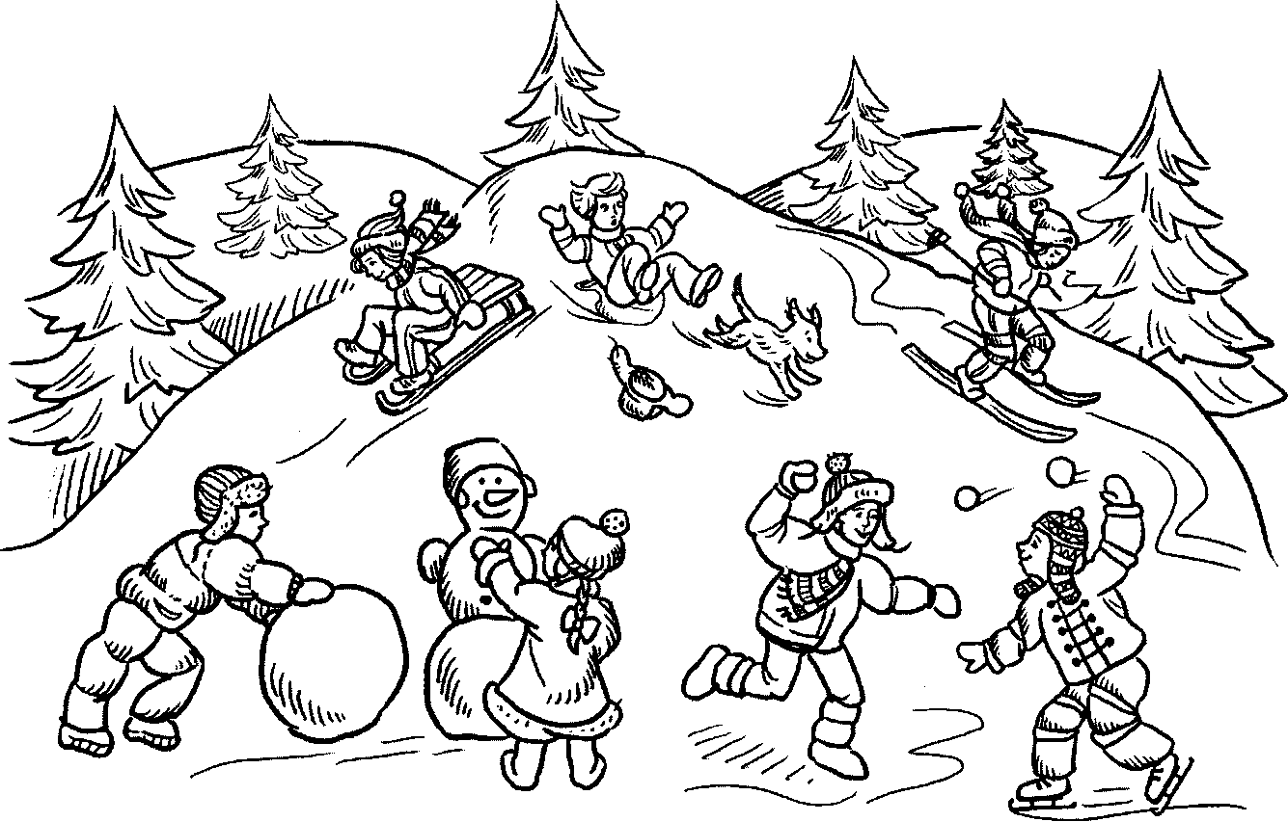

Playing snowballs

Making a snowman

Skating

Sledding

Skiing

____________________________________

______________________________________________________________________________________________

_______________________________________________________________________________________________

_______________________________________________________________________________________________

What do we wear in winter?

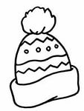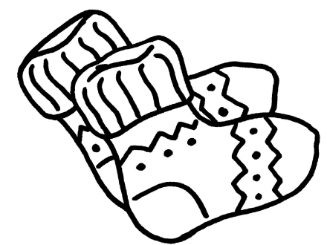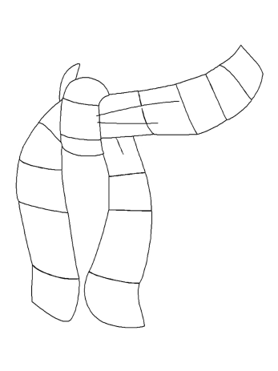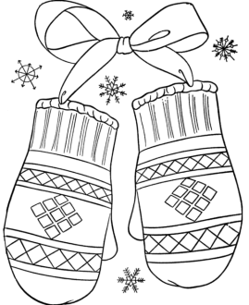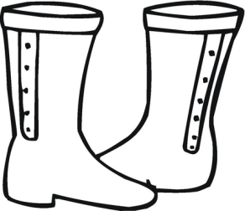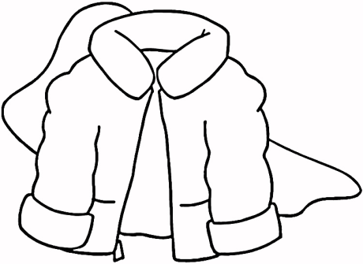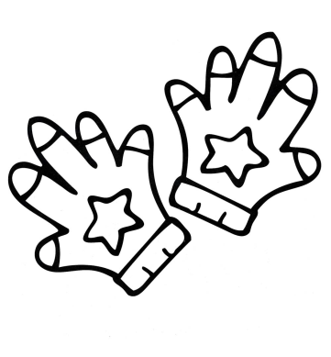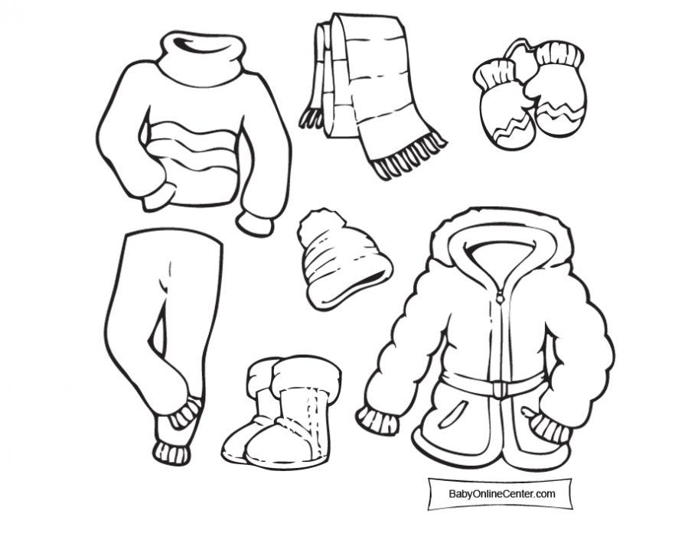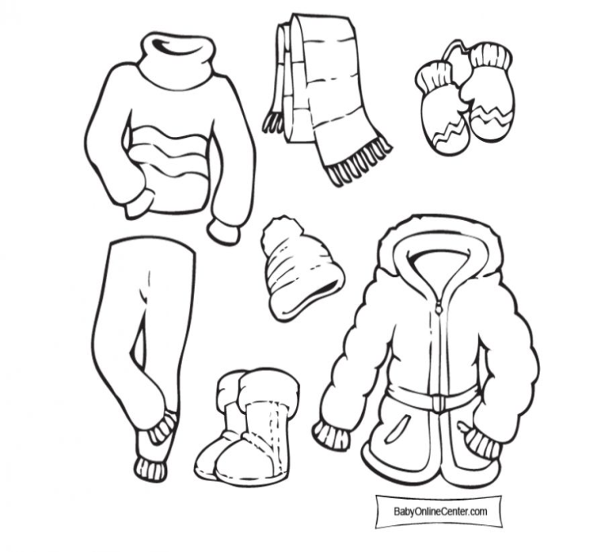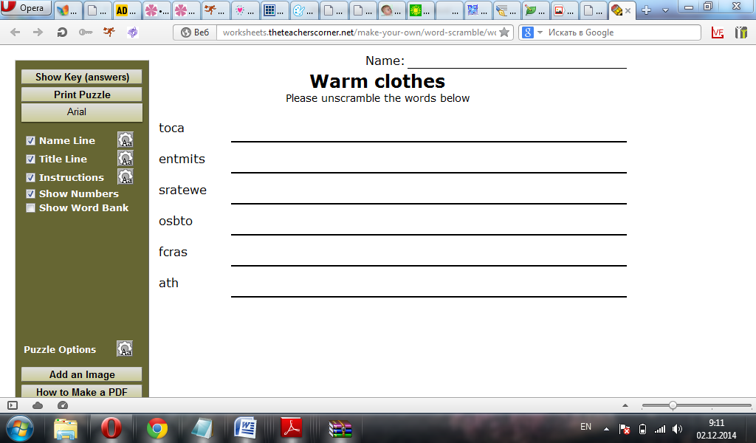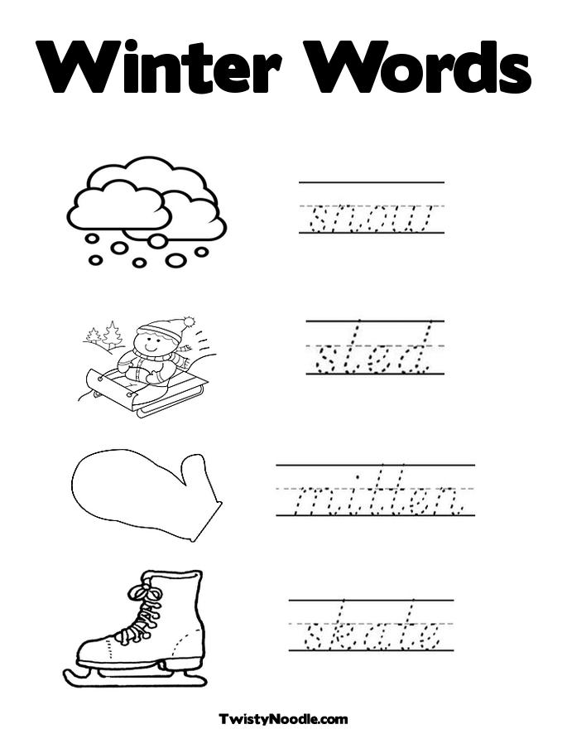

Write the words below

|  |
| --- |
| MITTENS |
| SNOW |
| SCARF |
| COAT |
| BOOTS |
| SLEDDING |

What do we wear in winter? What are your favourite clothes?Why?

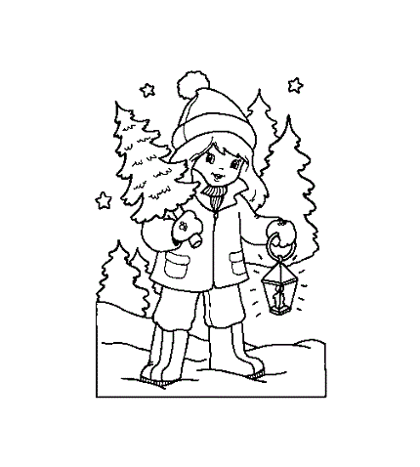

Colour girl’s hat red.

Colour girl’s coat purple.

Colour girl’s mittens pink.

Colour girl’s boots grey

Colour girl’s hair yellow.

Colour the trees green.

Colour the sky blue.

Colour the stars yellow.

Winter.

Winter… it seems, that the whole world is covered with snow. Even the sky is almost white.

Father and I play snowballs and make a big snowman. Some boys and girls skate, others-ski.

I can’t ski or scate. I take my sledge and go sledding with my friends… then we run home and drink warm tea or milk. It’s very cosy and nice at home in cold and frosty days.

I like to look at snowflakes. They dance and whirl in the air.

***

* Do you like winter?
* Of course, I do. We play snowballs, make snowmen, go sledding and have much fun.
* What colour is winter?
* It is white.
* Do you like to skate?
* I can’t skate, but I can ski a little.

**On a winter day**

Down comes the snow

On a winter day.

I make a snowman

When I go out to play.

**Winter**

The snow is falling,

The wind is blowing,

The ground is white

All day and night.

**Snowflakes**

Snowflakes are nice,

Snowflakes are white.

They fall by day,

They fall at night

Winter time is full of light,

Winter time is big and bright,

Winter time is full of fun,

Winter time has lots of sun.

**Winter.**

This is the season

When mornings are dark,

And birds do not sing

In the forests and park.

This is the season

When children ski

And Father Frost brings

The New Year Tree!

**New Year.**

New things to learn,

new friends to meet.

New songs to sing,

new books to read.

New things to see,

new things to hear.

New things to do

in this New Year!

**The snowman**

Look! We have a snowman,

He is tall and fat.

He has a carrot in his nose

He has a funny hat.

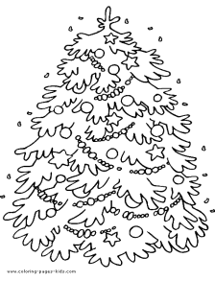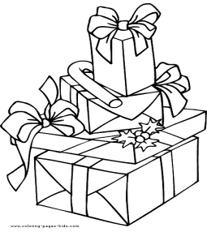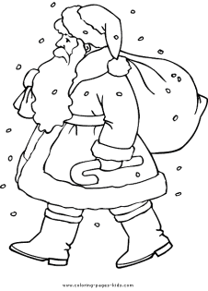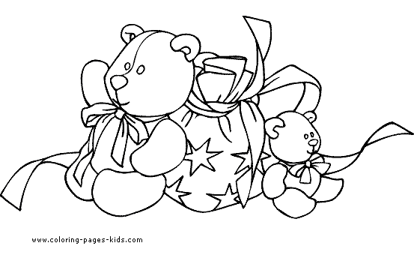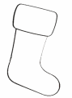

Christmas tree Presents Santa Claus Toys Stocking

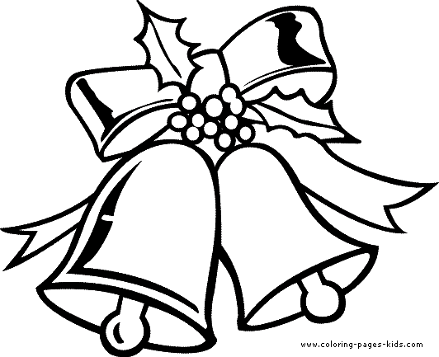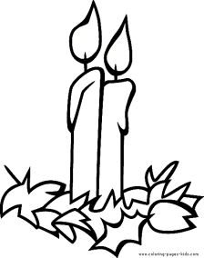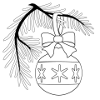

Bells Candles Bauble Christmas cards Turkey

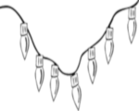

Crackers Cake Pudding Crackers Lights

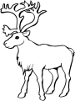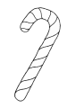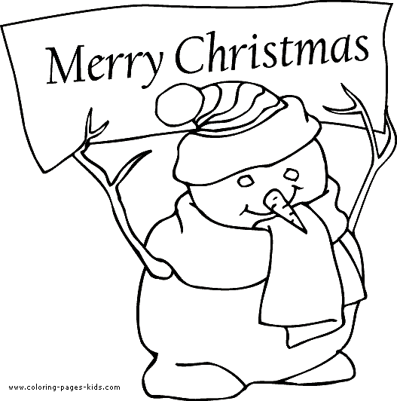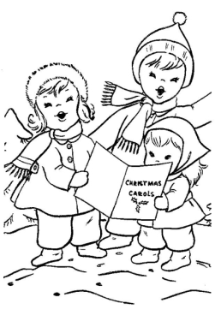

Deer Candy cane Candles Snowman Carols

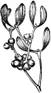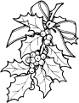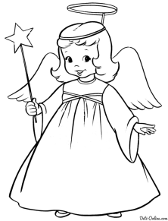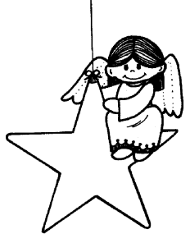

Mince pies Mistletoe Holly Angel Star



COLOUR THE STAR YELLOW

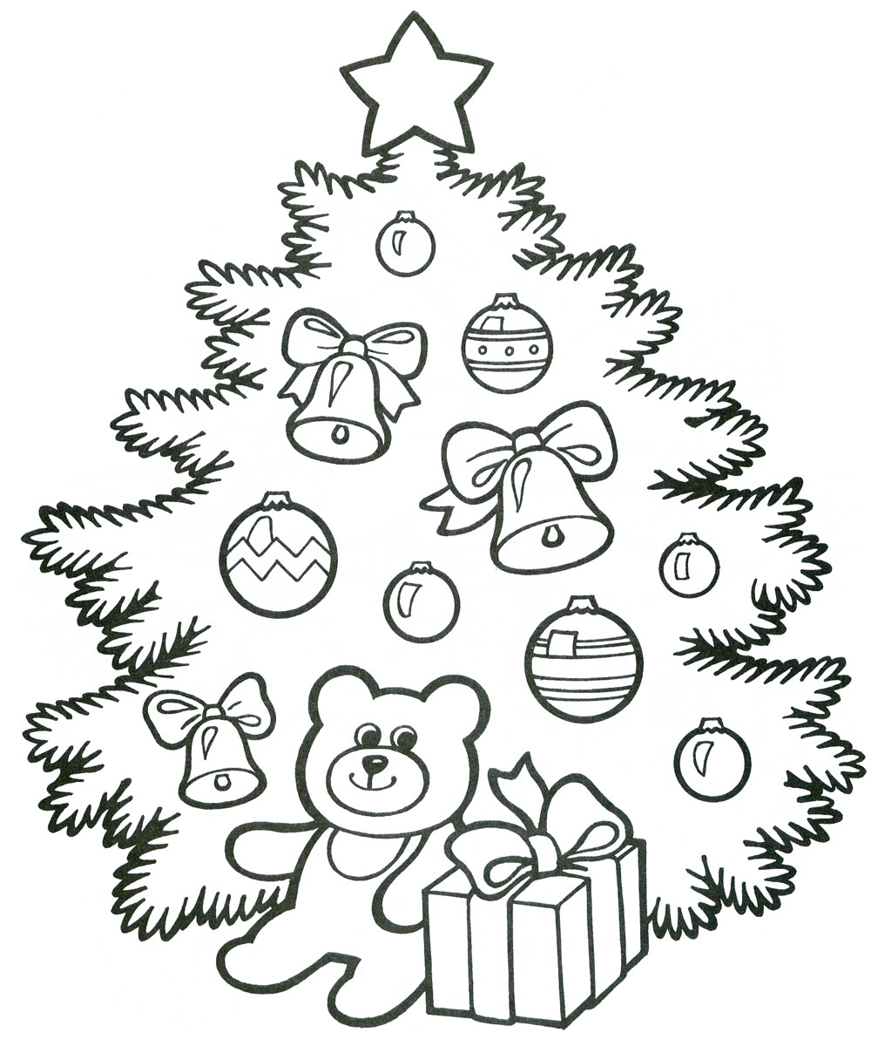

COLOUR THE BALLS BLUE

COLOUR THE BELLS GREEN

COLOUR THE RIBBONS RED

COLOUR THE BEAR BROWN

COLOUR THE PRESENT PINK

***Oh Christmas tree!***

***Oh Christmas tree,***

***How lovely are your branches!***

***Oh Christmas tree!***

***Oh Christmas tree,***

***How lovely are your branches!***

***In summer sun or winter snow***

***A coat of green you always show.***

Santa Claus

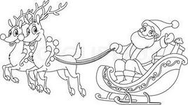

Hi! My name is Santa Claus. And this is Saint Nicholas. He lived in old times. He was very kind and helped all people. I got my name after him in 1863.

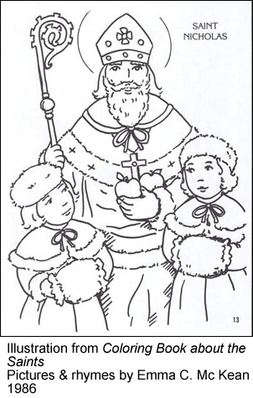

I’ve got two homes in the USA: one in Torrington, where I give presents, and one in the state of New York, where I live. I usually wear a red coat, a red hat and black boots. I travel in a sledge. But in warm sunny states I travel by ship or ride a surfboard. Isn’t it funny?

I love the time before Christmas. People go shopping, choose presents and send greeting cards. They decorate Christmas trees. But the 25th of December is the best time. People get together and spend Christmas with their families. For dinner I like to have turkey with vegetables, plum pudding and Christmas cake. And you?

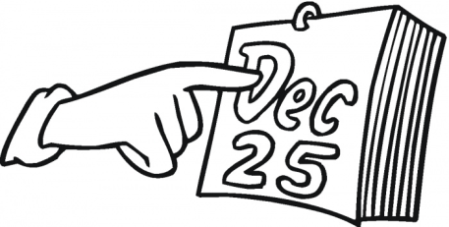

**Answer the questions:**

How did Santa Claus get his name?

Where does he live in the USA?

How does he travel?

What do Americans do before Christmas?

What do they do at Christmas time?

What does Santa Claus like for dinner?

______________________________________________________________________________________________________________________________________________________________________________________________________________________________________________________________________________________________________________________________________________________________________________________________________________________________________________________________________________________________________________________________________