Great Britain
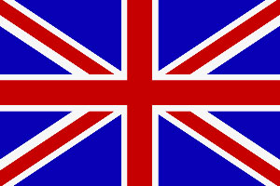
Great Britain is an island lying to the northwest of Continental Europe. It is the ninth largest island in the world, and the largest in Europe. With a population of approximately 58.9 million people, it is the third most populated island on Earth after Java and Honshū. It occupies an area of 209,331 km² (80,823 square miles). Ireland is to its west, and it is surrounded by over 1000 smaller islands and islets.
Great Britain stretches over about ten degrees of latitude on its longer, north – south axis. Geographically, the island is marked by low, rolling countryside in the east and south, while hills and mountains predominate in the western and northern regions.
It makes up the largest part of the territory of the sovereign state the United Kingdom of Great Britain and Northern Ireland and the term Great Britain is sometimes used inaccurately to mean the United Kingdom. England, Scotland and Wales are mostly situated on the island, along with their capital cities, London, Edinburgh and Cardiff respectively.
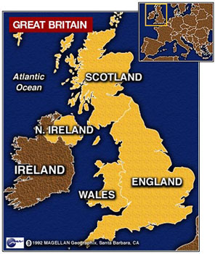
The Kingdom of Great Britain was the state resulting from the political union of the kingdoms of England and Scotland on 1 May, 1707 under Queen Anne. It existed until 1801 when Great Britain and Ireland united. The resulting United Kingdom of Great Britain and Ireland became the modern United Kingdom of Great Britain and Northern Ireland in 1922 with the secession of the Irish Free State.
Great Britain is the eastern island of the United Kingdom of Great Britain and Northern Ireland. Politically, Great Britain also refers to England, Scotland and Wales in combination, and therefore also includes a number of outlying islands such as the Isle of Wight, Anglesey, the Isles of Scilly, the Hebrides, and the island groups of Orkney and Shetland. It does not include the Isle of Man and the Channel Islands as they are not part of the United Kingdom, with independent legislative and taxation systems.
The union of the kingdoms of England and Scotland began with the 1603 Union of Crowns, a personal union under James VI of Scotland, I of England. The political union that joined the two countries happened in 1707, with the Acts of Union merging the parliaments of each nation, and forming the Kingdom of Great Britain, which covered the entire island.
In 1801, an Act of Union between Great Britain and Ireland created the larger United Kingdom of Great Britain and Ireland (UK). This in turn became the United Kingdom of Great Britain and Northern Ireland in 1922, following the partition of Ireland and the creation of the Irish Free State.
The terms Great Britain and England are sometimes mistakenly used to denote the United Kingdom. This error can be compared with the use of the term Russia to refer to the former USSR.

